**System Requirements**

This chapter describes the system requirements of Ping communication.

## **Introduction**

This document provides manual steps “Ping communication & Verification” .

## **Intended Audience**

## NEC Japan

## **System Requirements**

The following table describes the minimum software and hardware (SW/HW) requirements for ping communication.

|  |  |  |
| --- | --- | --- |
| **Details** | **VM1** | **VM2** |
| Purpose | TS server | MD server |
| OS | Windows 10 Pro Version 21H2 (OS Build 19044.1288) | Windows 10 Pro Version 21H2 (OS Build 19044.1288) |
| RAM | 8 GB | 8 GB |
| CPU Core | 4 | 4 |
| Disk Space | 500 GB | 500 GB |

**Table 1.1:** System Requirements

# Chapter 2

**Establish Ping Communication**

## **Ping Communication:**

## **How to use of Ping Communication:**

**Create Ping Communication script using PowerShell**

1. Open PowerShell IDE and paste below content(Code mention in step 1 only) into PowerShell.

**###Take variable value in Connection Log File Name**

**$ConnectionLogFileName="{{Var_file_download_dir}}\{{DB_ping_connection_test}}"**

**[string[]]$apserverip=@()**

**$resource_file_name= "{{Var_file_download_dir}}\{{ts_resources_json}}"**

**$JSON = Get-Content $resource_file_name | Out-String | ConvertFrom-Json**

**$webapserverip= @()**

**$webapserverip = $JSON.system.resources.tiers[0].{{server_type}}.servers**

**For ($i=0; $i -lt $webapserverip.Length; $i++){**

**### Get server ip from resource.jason**

**$apserverip= $JSON.system.resources.tiers[0].{{server_type}}.servers[$i].networkInterfaces.privateIp**

**if($apserverip -ne $null)**

**{**

**### ping app server ip**

**ping -n 4 $apserverip >> $ConnectionLogFileName**

**}**

**else**

**{**

**Write-Host "IP is not valid"**

**}**

**}**

2. Save the script with name the ‘ping_communication.ps1`

**Ping Communication** **using Manual**

* Open Start
* Open Command Prompt.
* Enter **ping <ip address> to** get a status of received and sent packets.

MD System Echo Request (Sent packets) TS System

Host Echo Request(received packets) Server

Fig.1.Ping Trouble Shooting

## **Evidence:**

* Local Execution with Evidence
* Execute the Below Command:

**ping -n 10 <ip_address> >>C:\Share\PingCommunication.log**

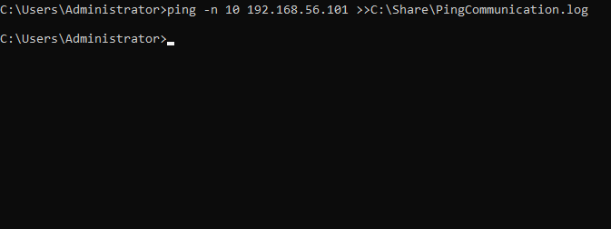

* Remote Execution with Evidence
* Execute the Below Command:

python

import winrm

s = winrm.Session('<ip_address>', auth=('<user_name>','<password>'))

r = s.run_ps(‘ping -n 10 <ip_address >> C:\Share\PingCommunication.log>’)

r.status_code 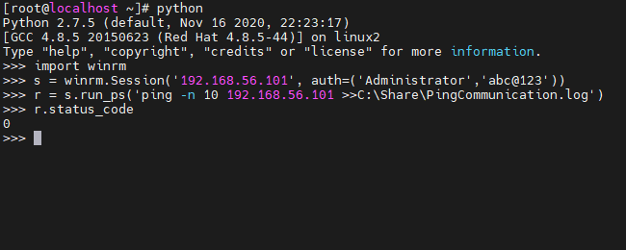

## **Verification:**

* Login to the MD machine
* Open file explorer
* Follow the path C:\Share\PingCommunication.log

